**CHATBOT IN PYTHON**

**Team member**

**aut71772114310: Srishivanth R F**

**PHASE 2: DOCUMENT SUBMISSION**

**DESCRIPTION:**

Chatbot is an application which has a database, it has an app l and APIs to call the other external administrations. However, bots cannot comprehend about what the customer has planned. It is a very much common problem that must be tackled. Bots are generally trained according to the past information which is only available to them so in most of the organizations, chatbot maintains their logs of discussions so that they can understand their customers character. Developers utilize these logs to analyze what clients are trying to ask. Developers coordinate with their client inquiries and reply with the best appropriate answer with the blend of machine learning tools and models. Training a chatbot is very much faster and also on a large scale as compared to human beings. A customer support chatbot is filled with a very large number of conversation logs which help the chatbot to understand what kinds of questions should be asked and answers should be given. While a normal customer service representatives are given manual instructions which they have to go through with.

**The chatbots is based on three methods:**

**1)Pattern Matches**: The pattern matches group of texts is utilized by the bots and it so it produces an appropriate response to the customers.

The standard structured model used for creation of these patterns is **“Artificial Intelligence Markup Language”.**

**2) Natural Language Understanding (NLU)**: Finding the way to convert the user’s speech or text into structured data is called natural language Processing. It is used to get relevant answers for the customers. To develop a chatbot one must be very clear about what one wants from that chatbot. often they are developed for business platforms like Net Banking sites to handle costumer Q&A. Another type of chatbot is widely developed and used are smart assistants like Google assistant, Siri, Alexa, Cortana etc.

**How to Make a Chatbot in Python?**

**1. Preparing the Dependencies**

The right dependencies need to be established before we can create a chatbot. Python and a Chatterbot library must be installed on our machine. With Pip, the Chatbot Python package manager, we can install Chatterbot.

**2. Creating and Training the Chatbot**

Once the dependence has been established, we can build and train our chatbot. We will import the Chatterbot module and start a new Chatbot Python instance. If so, we might incorporate the dataset into our chatbot's design or provide it with unique chat data.

**3. Communicating with the Python chatbot**

We can send a message and get a response once the chatbot Python has been trained. Creating a function that analyses user input and uses the chatbot's knowledge store to produce appropriate responses will be necessary.

**4. Complete Project Code:** We will give you a full project code outlining every step and enabling you to start. This code can be modified to suit your unique requirements and used as the foundation for a chatbot.

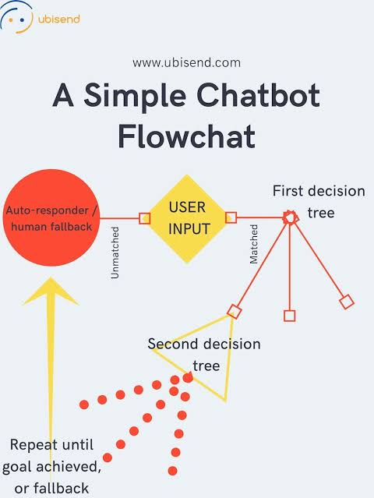

**Here are some innovative ideas for using chatbot in python:**

**1. Mental Health Support**: Develop a chatbot that offers mental health support, guidance, and resources to individuals who may be struggling with stress, anxiety, or depression.

**2. Language Learning Assistant**: Build a chatbot that helps users learn a new language by providing lessons, quizzes, and conversation practice.

**3. Career Advisor**: Create a chatbot that assists job seekers with resume building, interview tips, and job search recommendations based on their skills and aspirations.

**4. Healthcare Information**: Develop a chatbot that provides medical information, symptom checkers, and advice on managing common health conditions.

**5. Travel Planner**: Build a chatbot that helps users plan their vacations by suggesting destinations, booking flights, hotels, and providing travel tips.

**6. Financial Advisor**: Create a chatbot that offers financial advice, budgeting tips, and investment recommendations tailored to users' financial goals.

**7. Cooking Assistant**: Develop a chatbot that helps users find recipes, create shopping lists, and guides them through cooking processes step by step.

**8. Educational Tutor**: Build a chatbot that offers tutoring in various subjects, helping students with homework, practice questions, and explanations.

**9.Event Planner**: Create a chatbot that assists in planning events, such as weddings or parties, by suggesting venues, managing guest lists, and providing event ideas.

**10.Customer Support**: Enhance customer service by using chatbots to provide quick responses to common queries and direct users to the appropriate resources or human agents when needed.

**11.News and Content Recommendations**: Develop a chatbot that delivers personalized news updates, articles, videos, and book recommendations based on users' interests.

**12.Fitness Coach**: Create a chatbot that offers workout routines, nutrition advice, and tracks users' fitness progress.

**13.Real Estate Assistant**: Build a chatbot that helps users search for homes, apartments, or commercial properties based on their criteria and budget.

**14.Environmental Sustainability**: Develop a chatbot that educates users on sustainable practices, offers eco-friendly product suggestions, and tracks their environmental impact.

**Example for chatbot:**

* + - Visual dialog chatbot
    - Real Estate chatbot

**What problems do chatbots solve?**

Chatbots can basically solve any issues a customer or prospect may have. Previously chatbots have been used exclusively in this way for customer support. However, now the focus is shifting more and more to lead identification, activation and conversion. From a marketing perspective, Chatbots take all the hard work you’ve done with your inbound marketing campaigns and make sure that every prospect that visits your site is activated and engaged. This means that you are maximize the potential opportunities present in every visitor to your site.

**A chatbot can do of the following**:

* Guide a visitor to the right place on your site
* Identify the best product or service for their needs
* Gather contact information for sales and retargeting
* Gather data about customer interests and behaviour
* Qualify them as MLQ or SQL and link them up to a sales rep.

**Creating a chatbot in python programming:**

I hope you now have understood what are chatbots and why so many companies use them to solve the most common problems of their customers. Now let’s see how to create a chatbot with Python. Here, I will be using the NLTK library in Python which is one of the best Python libraries for any task of natural language processing. Now I will be creating a list of queries and their responses for the chatbot:

#Pairs is a list of patterns and responses

pairs = [

[

r"(.*)my name is (.*)",

["Hello %2, How are you today?",]

],

[

r"( .* )help(.*) ",

["I can help you ",]

],

[

r"( .* ) your name ?",

["My name is the clever programmer, but you can just call me robot and I'm a chatbot.",]

],

[

r" how are you (.*) ?",

["I'm doing very well", "I am great!"]

],

[

r" sorry (.*)",

["It’s alright ","It’s OK, never mind that",]

],

[ r" I'm (.*) (good |well |okay |ok)",

["Nice to hear that ","Alright, great!",]

],

[

r"(hi |hey |hello |hola |holla )(.*)",

["Hello", "Hey there",]

],

[

r" what (.*) want ?",

["Make me an offer I can't refuse",]

],

[

r"(.*)created(.*)",

["Aman Kharwal created me using Python's NLTK library ","top secret ;)",]

],

[

r"(.*) (location |city) ?",

['New Delhi, India',]

],

[

r"(.*)raining in (.*)",

["No rain in the past 4 days here in %2","In %2 there is a 50% chance of rain",]

],

[

r" how (.*) health (.*)",

["Health is very important, but I am a computer, so I don't need to worry about my health ",]

],

[

r"(.*)(sports |game |sport)(.*)",

["I'm a very big fan of Cricket",]

],

[

r" who (.*) (Cricketer |Batsman)?",

["Virat Kohli"] ], [ r" quit", ["Bye for now. See you soon :) ","It was nice talking to you. See you soon :)"]

],

[

r"( .*)", ['That is nice to hear'] ],

]

Now let’s run this program and interact with the chatbot by using some of the queries related to the queries mentioned in the above list:

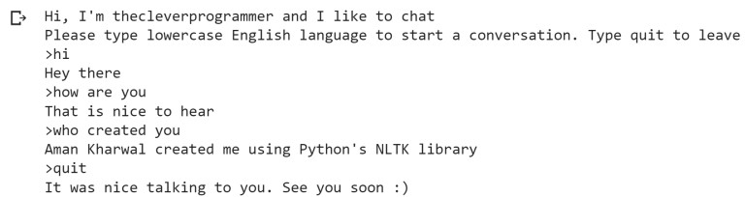

**Summary**

Chatbots are very useful applications for every company especially if a company is providing any type of service. It helps an organization by solving the most common queries of the customers. I hope you liked this article on how to create a chatbot using Python.